Yelp: <https://www.yelp.com/biz/tarntip-thai-cuisine-corvallis>

About: Enjoy the most delicious Thai food and the spacious seat you can have a good meal with your friends. We have spicy food, sour food, and other different flavors of curries. You can always find a kind of curry you want to eat. Try our traditional cuisine, they won’t let you down.

Tofu tod - $5.95

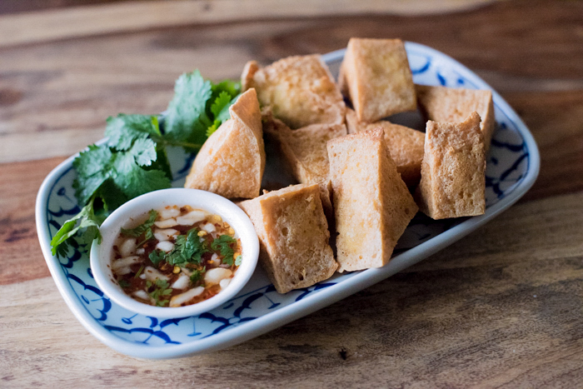

Pot stickers - $6.95

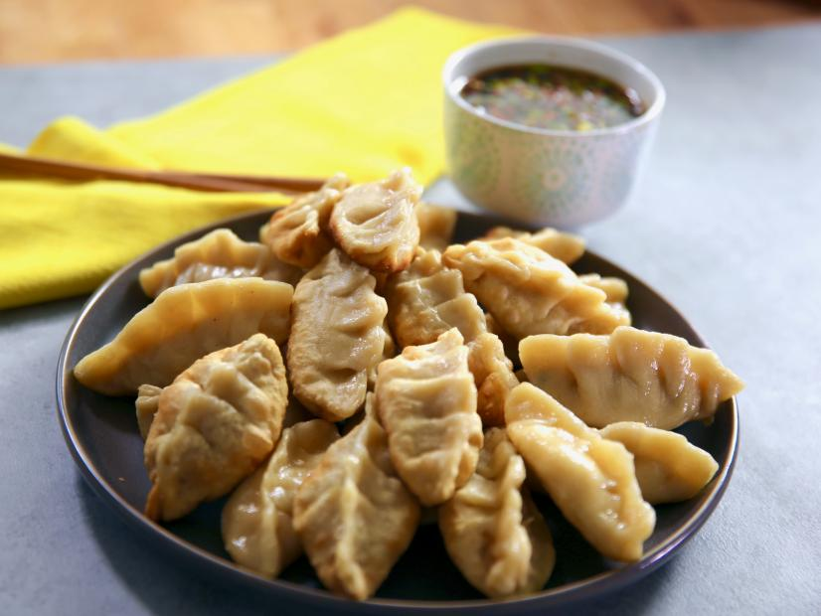

Siam shrimp - $7.95

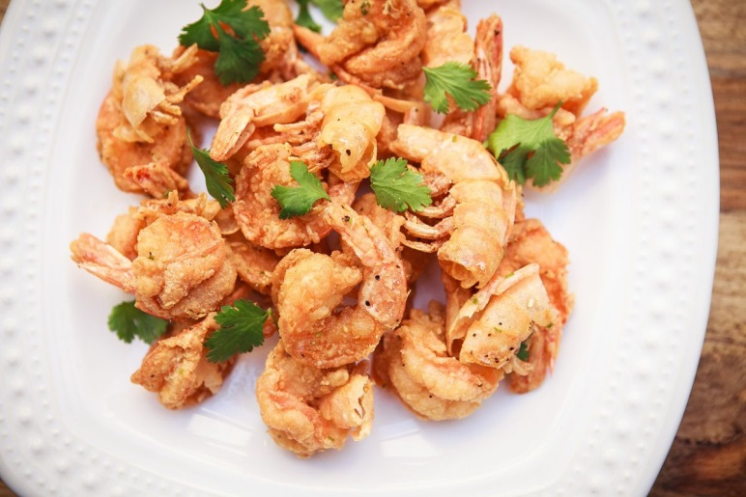

Tom yum goong - $13.95

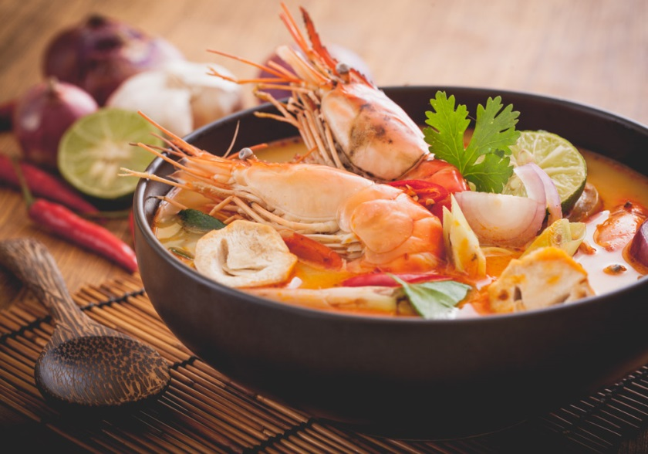

Nuah yum - $9.95

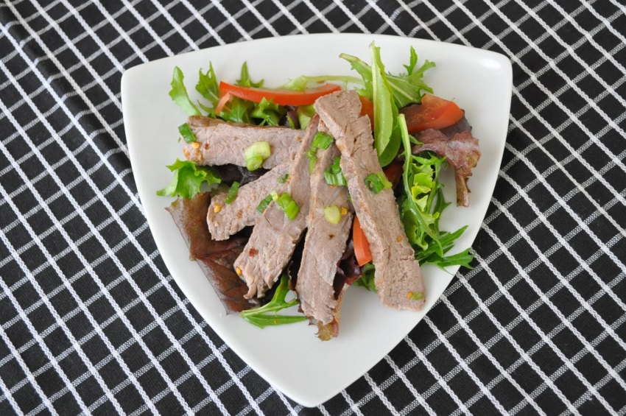

Laab – $9.95

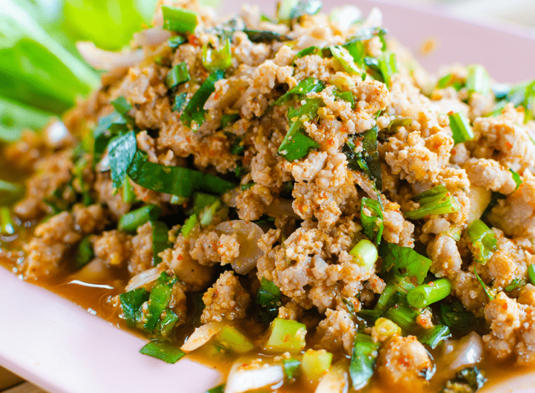

Num tok - $9.95

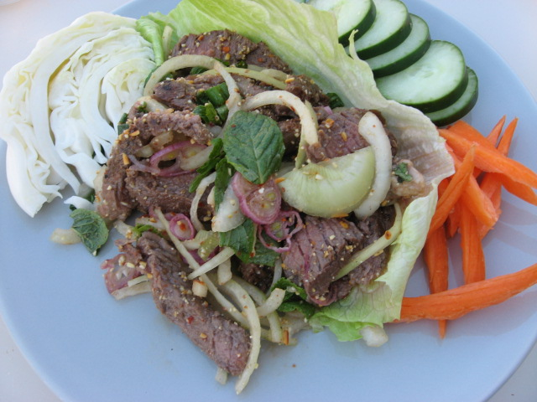

Garlic fish - $15.95

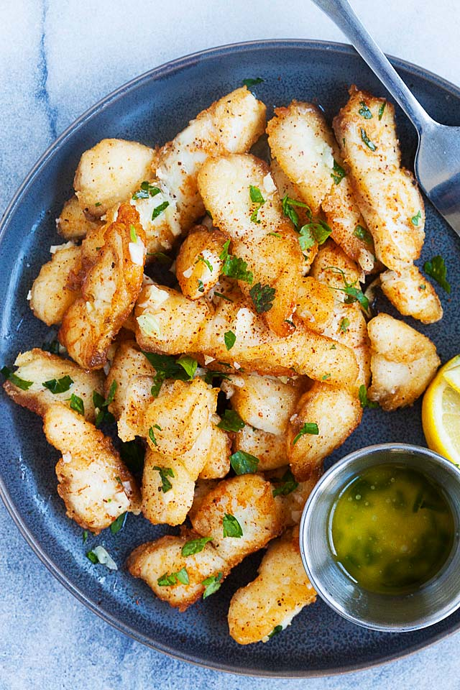

Fish curry - $15.95

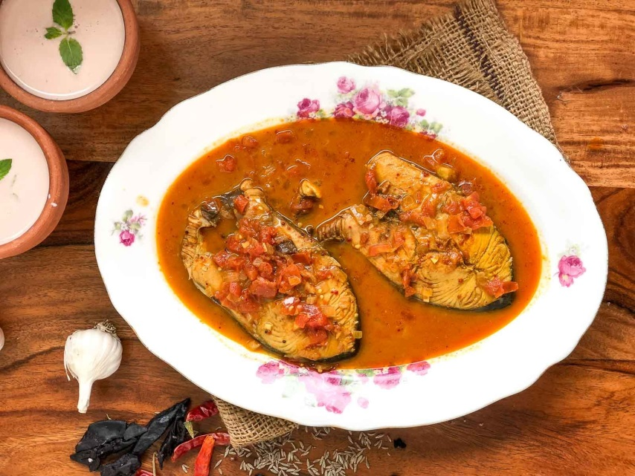

Tofu delight - $11.95

